
2024 - 2025

School Education & Literacy Department, Government of Sindh
RFP-6, Package-1, District Karachi Schools being managed by
Sindh Madressah-tul-Islam Board

Yearly Progress Report


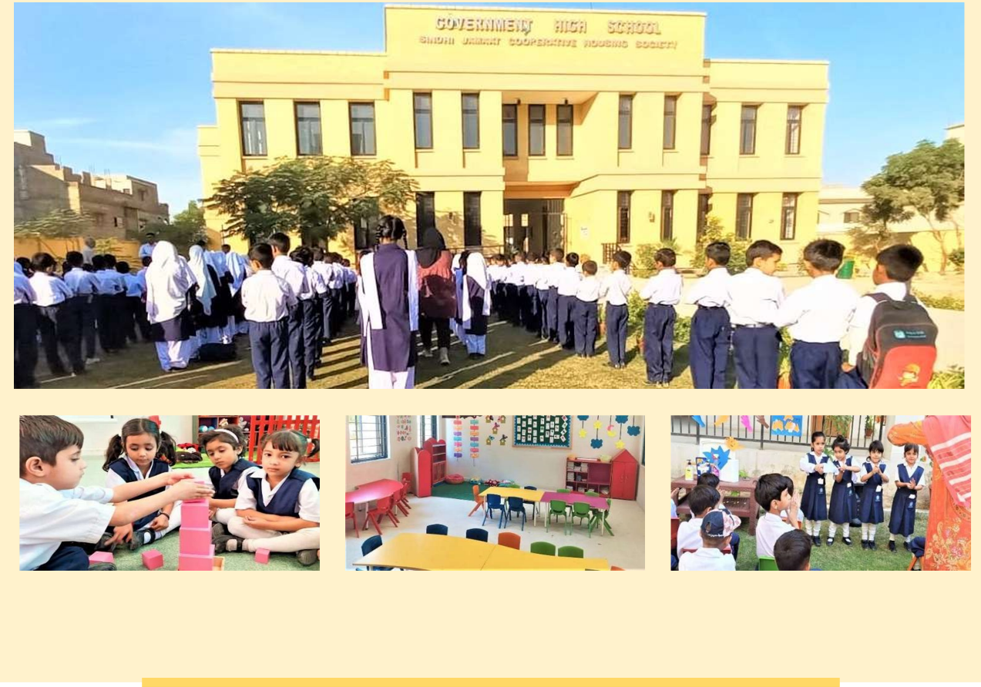
Submitted by:

Sindh Madressah-tul-Islam Board
(Educational Management Organization)
To:

Teacher Resource Center
(Independent Expert)
SMB Teaching Staff Available in Schools
S. No | Name | Designation | Program | CNIC No | Date of Joining
1 | Syeda Samiya Kazmi | Principle | EMO | 41304-8178382-2 | 06-Oct-2021
2 | Miss Shumaila | Directress | EMO | 42501-6902056-2 | 01-Jul-2022
3 | Miss Saika | Teacher | EMO | 42501-7160658-6 | 01-Aug-2022
4 | Miss Tooba | Teacher | EMO | 42501-8210999-2 | 01-Aug-2022
5 | Miss Saba | Teacher | EMO | 43203-9105637-2 | 01-Aug-2022
6 | Miss Shehzana | Teacher | EMO | 42301-0658911-0 | 01-Aug-2022
SMB Non-Teaching Staff Available in Schools
S. No | Name | Designation | Program | CNIC No | Date of Joining
Govt. Teaching Staff Available in Schools
S. No | Name | Designation | Program | CNIC No | Date of Joining
Govt. Non-Teaching Staff Available in Schools
S. No | Name | Designation | Program | CNIC No | Date of Joining

Enrollment Status of Students
S. No | Class | Boys |  | Girls |  | Total
1 | E.C.E | 40 |  | 36 |  | 76
2 | I | 17 |  | 16 |  | 33
3 | II | 15 |  | 10 |  | 25
4 | III | 12 |  | 15 |  | 27
5 | IV | 16 |  | 7 |  | 23
6 | V | 11 |  | 8 |  | 19
Total |  | 90 |  | 69 |  | 159
Dropout Status of Students
S.No | Boys |  | Girls |  | Total
1

